Bank Marketing Case Study

Will the Term Deposit be Subscribed by the client?

# Executive Summary

This project is based on the case study for a bank marketing strategy with the objective of predicting if the clients would subscribe to the term deposit for the marketing campaign to be successful. The dataset for the project is taken from the machine learning website - UCI for a Portuguese banking institution. The project covers the use of the model logistic regression for predictive modeling.

Table of Contents

Executive Summary 1

The Problem 2

Literature Review 2

Methodology 3

Data 4

Exploring the dataset 5

Findings 8

Conclusion and Recommendation 15

Appendix 16

References 16

Plots 17

Code for the model 33

# The Problem

The dataset for this project is from a Portuguese banking institution and their marketing campaign done via phone calls. The aim behind this case study is to predict if the clients would subscribe to a term deposit with the bank and is denoted by the variable y in the dataset, which is also the target variable. Because the data was collected through phone calls, it often took more than the first call with the clients to question the term deposit with the bank.

The target variable for the project is the yes/no binary value about the client’s subscription to the term deposit by building an algorithm using the classification method of logistic regression. The dependency is built upon the accuracy of the results generated by the algorithm and the results are tested upon the f-scores of the model.

# Literature Review

The results obtained showed the KNN model 3 to be the best model from their research paper for the dataset bank-full.csv among the four datasets of the case study and this dataset has all the examples and 17 inputs and is ordered by date For the case study, the authors analyzed the data individually of all the 17 features before proceeding with the preparation of data where the models were compared with their accuracy, sensitivity, specificity, precision, and the negative predictive value. The authors then proceeded to use the KNN model, Linear Model and logistic regression for their predictive modeling and summarized their results at the end referring to the third KNN model to be the most suitable one which had the accuracy value of 0.91, sensitivity of 0.16, specificity of 0.91, precision of 0.01 and the negative predictive value of 0.99 (Wlodarczyk, Ikani, 2020).

This research paper used the same dataset as the one used for this project: bank-additional.csv. For this project, they made use of 15 different algorithms:

* four different models with a Bernoulli response for the generalized linear models
* standard linear regression model
* naïve Bayes classifier
* three discriminant analysis algorithms
* four SVM with different kernels

For this paper, they used a randomized 10% of the dataset as test dataset and the remaining was used to train the dataset. They kept a comparison summary to show their results from all the different models and concluded the GLM with the probit link function to be the best model for the dataset. They also concluded that the risk value was good with the value of 0.30 or lower for all the algorithms and yet the best of the risk value was achieved with the non-GLM techniques (Laureano, 2018).

# Methodology

The dataset used for this project is the bank-additional.csv among the four of the datasets accumulated originally for this case study and the chosen dataset is the 10% of the examples randomly selected. There are a total of 20 features/input variables for the dataset with 1 output variable (y) which is the binary yes/no answer value for the subscription of the term deposit in the bank by the clients.

The dataset holds 10 numerical values and 10 categorical values. The description of the features is explained below:

The numerical features are:

* Age: age of the client
* Duration: last duration of contact in seconds
* Campaign: number of contacts performed during this campaign and for the client
* Pdays: number of days passed since last contact from previous campaign
* Previous: number of contacts performed before the campaign
* Emp.var.date: employment variation rate
* Cons.price.idx: consumer price index
* Cons.conf.idx: consumer confidence index
* Euribor3m: Euribor 3-month rate
* Nr.employed: number of employees

The numerical features are:

* Job: type of job of the client
* Marital: marital status of the client
* Education: education of the client
* Default: has default credit
* Housing: has housing loan
* Loan: has personal loan
* Contact: type of communication with the client
* Month: last contact with the client in terms of month
* Day_of_week: last contact with the client in terms of week
* Poutcome: outcome from the previous marketing campaign

The variables can also be classified in terms of different categories such as the data of the client, data from the campaign and then the economic attributes. As such, the initial data exploration gives us the results as below.

The model being used for the classification of the data is a parametric model, which is the logistic regression model. It is also known to be a generalized form of a linear model. As such, parametric models have assumptions of the distribution underneath it and this could be a violation in the real world as this stand as a limitation with parametric models.

Also, for training and testing, we split the dataset into a 75% and 25% split with 75% of the randomized data from the dataset for training the model and the remaining 25% for testing. We also used an AIC model to avoid the over-fitting and to compare the relative goodness-of-fit for the best model. And we also used VIF after the use of AIC to check the multicollinearity between the features. We covered the threshold moving by referring to resources online since we have not been able to grasp the concept completely, which is also a limitation regarding the results perceived. The referred research showed the concept on how to use the cutoff on unbalanced data in R (Unal, 2017).

# Data

The actual dataset that was used for the project had very unbalanced data. The data was clean with no missing values in the dataset. However, in various instances, we found that there were the variables “unknown” for some data that was missing. This high imbalance in the dataset stood to be a major hurdle and to overcome this limitation there are a few methods to go about it in general- from cutoff/ moving the threshold, resampling of the data: oversampling and under sampling. As per the research conducted by Branco, Torgo and Ribeiro in 2015, regarding building a classification algorithm, dealing with unbalanced data is crucial and can be done within:

* Modification on the learning algorithm
* Changing the data before training it and
* Applying necessary transformation to the prediction of the training dataset (Branco, Torgo and Ribeiro, 2015).

Among these methods, the choice of method used here was cutoff/ threshold moving. This method is an alternative in handling imbalanced data. We deleted approximately 20% of the unknown variables from the dataset. We also removed only two variables – duration and pdays initially. The reason behind removing the variable duration is because it didn’t seem viable as it didn’t seem to have a strong influence with the model as well as a strong correlation with the target variable. In the dataset, we also converted the character variables as numeric so that we can run pairwise comparison. Since there are too many data points falling apart from the median, we can consider that there is high variance specially with the features age, duration, and campaign.

## Exploring the dataset

In this section, we explored the dataset to get information about the dataset at hand and understand how the data is distributed as well as how it is related with the target variable.

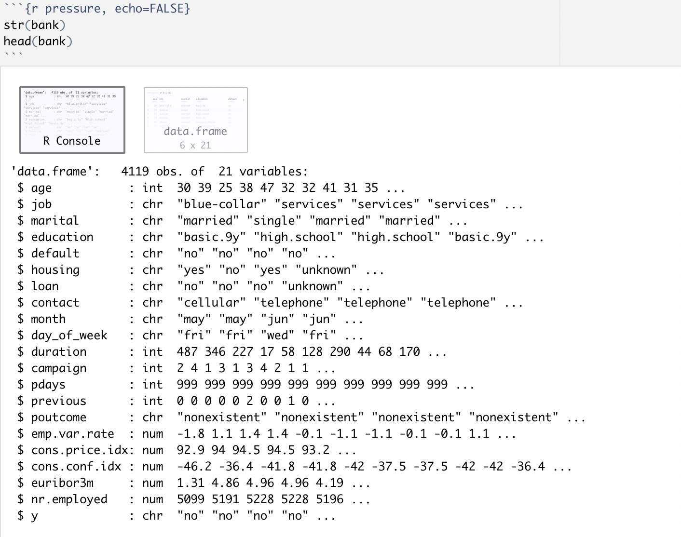

*Fig: Data frame of the dataset*

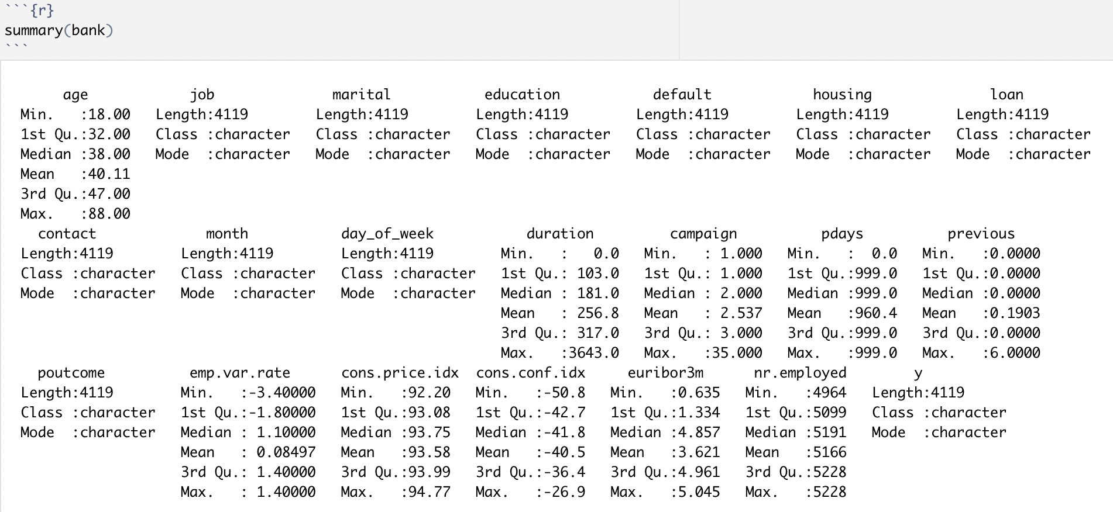

*Fig: Summary of the dataset*

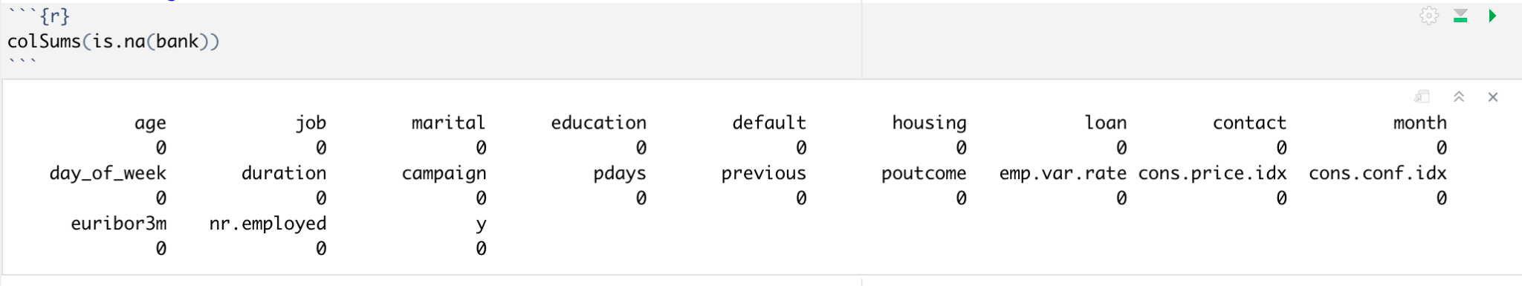

*Fig: Checking to see null values in the dataset*

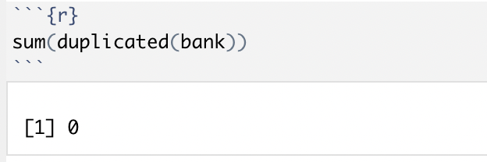

*Fig: Checking to see if there is any duplicate data in the dataset*

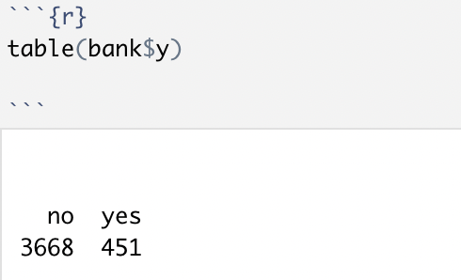

*Fig: Checking the values of the variables of the target feature to check balance of data*

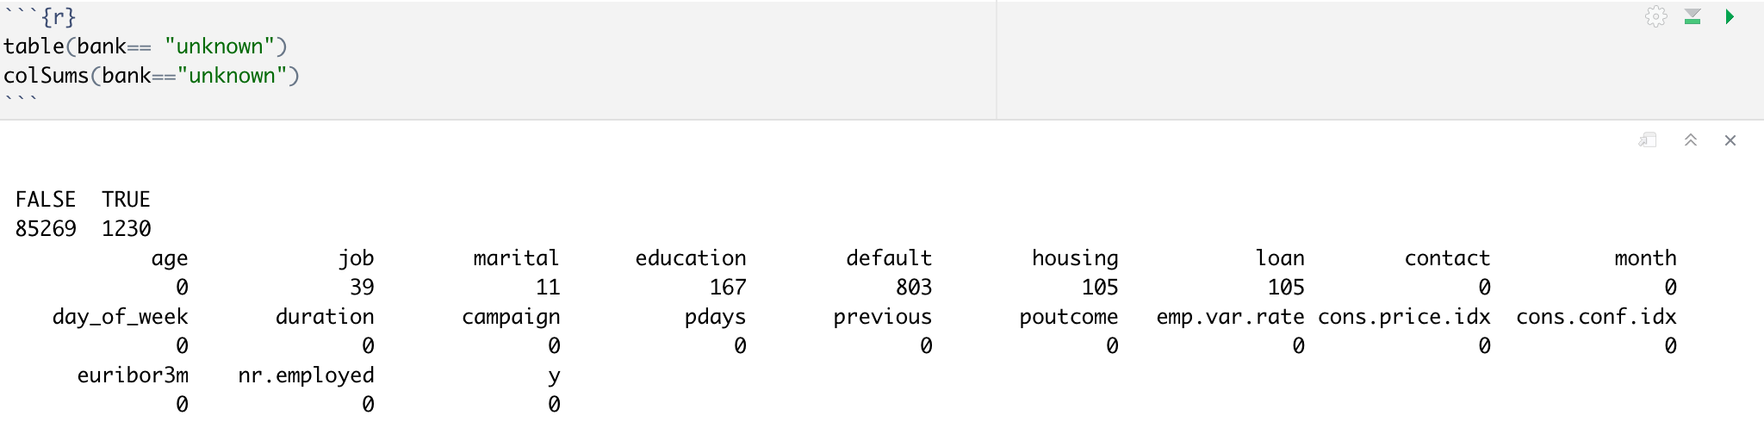

*Fig: Looking at the unknown variables in the dataset*

All of this was the basic visualization to understand more about the data and get information from it. After the exploratory data analysis, we went forward to analyze the collinearity of the variables with the target variable. The plots and results for it have been included under the appendix section titled “plots”. Here, we concluded that the age distribution shows that the majority of the bank's customers are aged between 25 - 50. More specifically, 50 % are between 32-47. The median age is 38. So, the target customers of the bank might be middle-aged adults.

# Findings

Initially, we eliminated two variables- pdays and duration. Our first model included all the variables as predictors for the model. The result for all the models is shown below simultaneously.

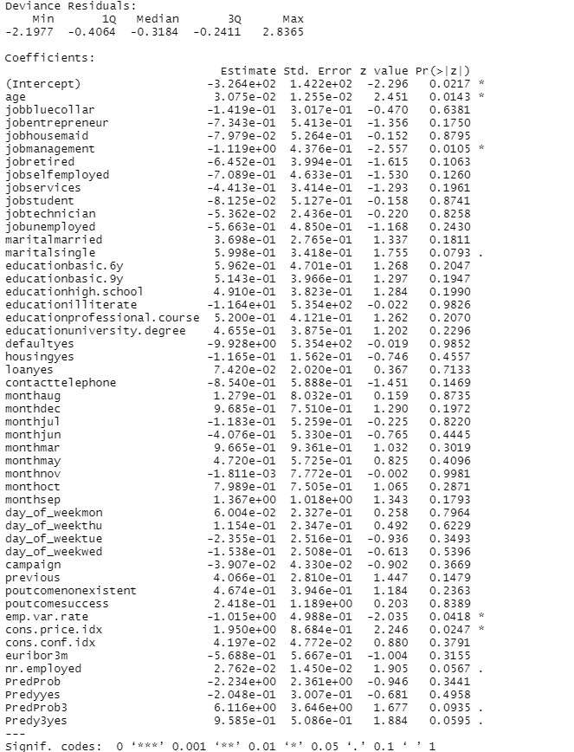

*Fig: Model Result 1*

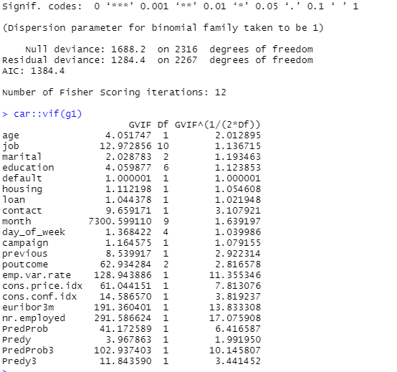

*Fig: Model Result 1 (AIC & VIF)*

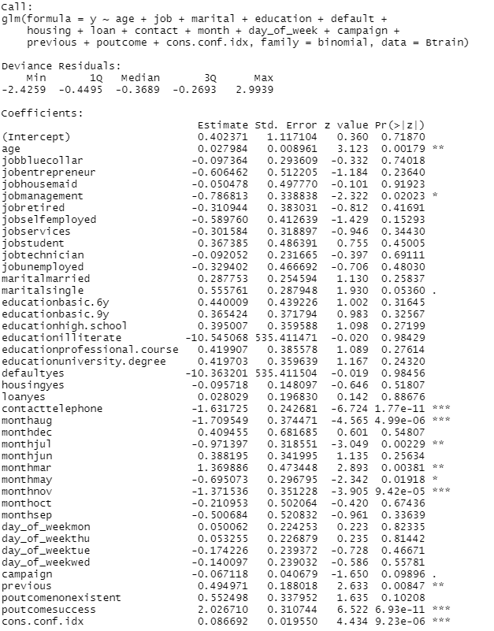

*Fig: Model Result 2*

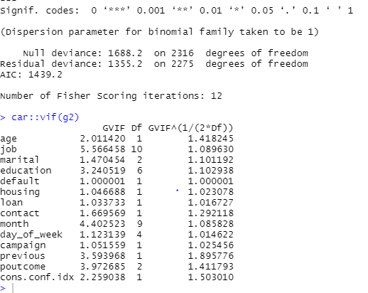

*Fig: Model Result 2 (AIC & VIF)*

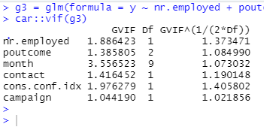

*Fig: Model Result 3 (from AIC)*

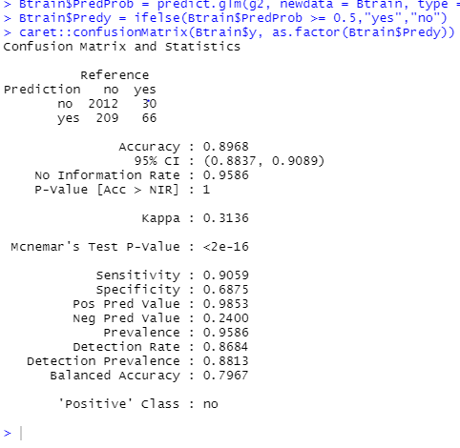

*Fig: Results for Model 1 (with all the variables)*

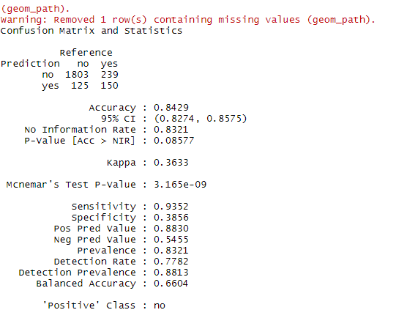

*Fig: Results for Model 2 (after the threshold moving/cutoff)*

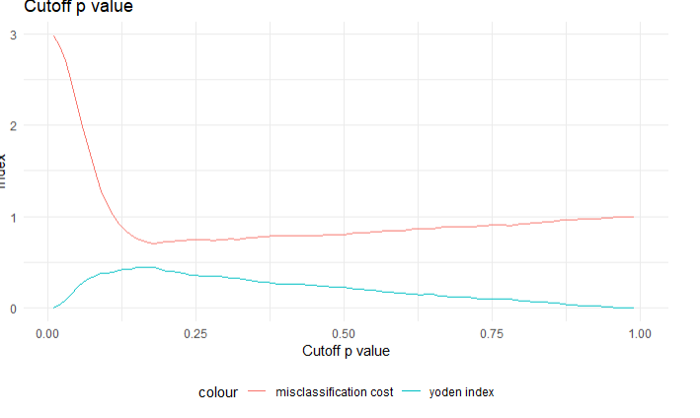

*Fig: Cutoff p-value Graph*

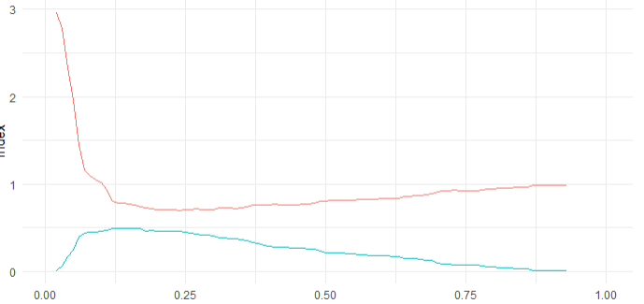

*Fig: ROC Graph*

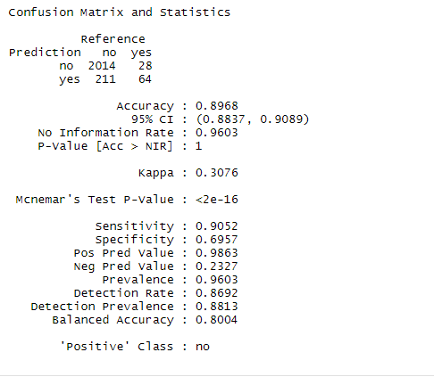

*Fig: Results for Model 3 (after the AIC model)*

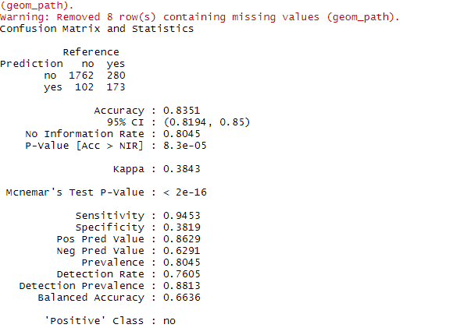

*Fig: Results for Model 3 (after the cutoff/threshold moving)*

Multicollinearity occurs when the independent variables are too highly correlated with each other. We used VIF on the significant variables (after removing the insignificant variables), i.e., on the second model named “g2”. Next, we also removed all the features where the VIF value was over the value of 10. For the model, we considered a cutoff of 0.14 for model 1 and 0.13 for the third model. For 0.14, since the misclassification cost and the Yoden index starts separating at this point and for 0.13, the sensitivity cost and the specificity starts separating at this point. For any model, the higher the VIF then there is higher multicollinearity within the variables. Thus, we removed these variables with high multi-collinearity to get a perfect separation model.

Therefore, from all the result above, we have concluded that our null and alternate hypotheses are:

H0: If the model says that customers subscribe for the term deposit then they are more likely to subscribe (i.e., all the value of the mean is the same)

Ha: If the model says that customers subscribe for the term deposit then they are not likely to subscribe (i.e., all the value of the mean is not the same, at least one is different).

From all the tested models we concluded that the model after the AIC selection provided the best results with the accuracy point of 89% with the highest multicollinearity, which is the second model. However, the most optimal model is the third model which was executed after the AIC selection. As per our findings from all the three models, pdays, loan, housing and duration are not good predictors for the target variable and predictors such as job and education are good predictors for the target variables and poutcome, month and contact are fair predictors for the model.

# Conclusion and Recommendation

From the many different materials referred to of the existing models used for the dataset, we can find that the differences between them was dependent on the predictors that were used for the target variable. While some papers concluded that the KNN model would be best, the others suggested XGBoost to be better for the dataset. We used logistic regression for our model as per the instructor’s requirements for the case study. The imbalance of the data was one of the major limitations that we came across which was overcome by the method of threshold moving.

In a generalized answer, Random Forest classification is considered to be one of the dominant classification algorithms as it is known to be capable of both classification as well as regression. However, logistic regression has advantages with easier implementation and interpretation and is efficient in training the dataset. Also, with severe unbalanced data, logistic regression is a better model to work with since it does not suffer as severely. Because our dataset is a multivariate, the best goal is to aim to find the equation that would be the best predictors for the binary response target variable (y).

There could be various other factors affecting the outcome and the accuracy of the result however, if we are focusing on prediction, then logistic regression model was found to be with the highest accuracy amongst the existing models. Recommendation for better results would be to test the dataset with more models such as random forest, SVM, KNN or decision trees. Clustering the dataset in terms of a set requirement so that the segments could give viable results can also be done to improve the accuracy of the model. We could also work on a better model by removing other variables such as housing, loan, pdays, duration that could improve the accuracy of the model better.

# Appendix

## References

* Laureano, H., 2018. *An overview of classification algorithms*. [online] Available at: <https://henriquelaureano.github.io/courses/ml-kaust/project_report.pdf> [Accessed 12 February 2022].
* Branco, Torgo, Ribeiro, P., 2015. *A Survey of Predictive Modelling under Imbalanced Distributions*. [online] arxiv, pp.1 - 32. Available at: <https://arxiv.org/pdf/1505.01658.pdf> [Accessed 10 February 2022].
* Włodarczyk, Kinga & Ikani, Kingsley. (2020). *Data Analysis of a Portuguese Marketing Campaign using Bank Marketing data Set* [online] Research Gate, Available at:

<https://www.researchgate.net/publication/339988208_Data_Analysis_of_a_Portuguese_Marketing_Campaign_using_Bank_Marketing_data_Set/citation/download>[Accessed 9 February 2022].

* Unal, I., 2017. *Defining an Optimal Cut-Point Value in ROC Analysis: An Alternative Approach*. [online] Hindawi. Available at: <https://www.hindawi.com/journals/cmmm/2017/3762651/> [Accessed 11 February 2022].

## Plots

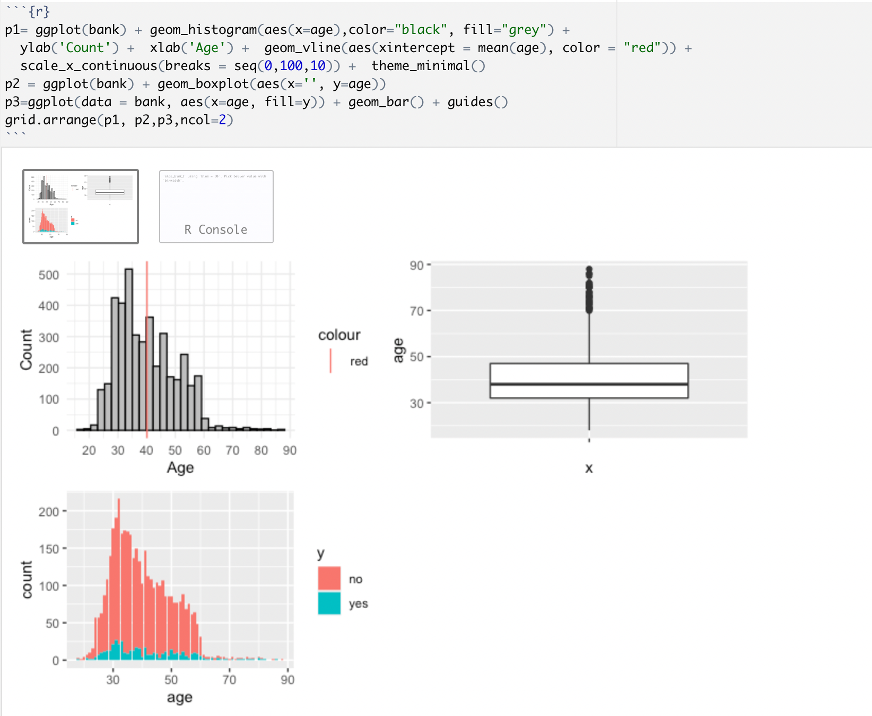

*Fig: collinearity check between the variable age and the target variable*

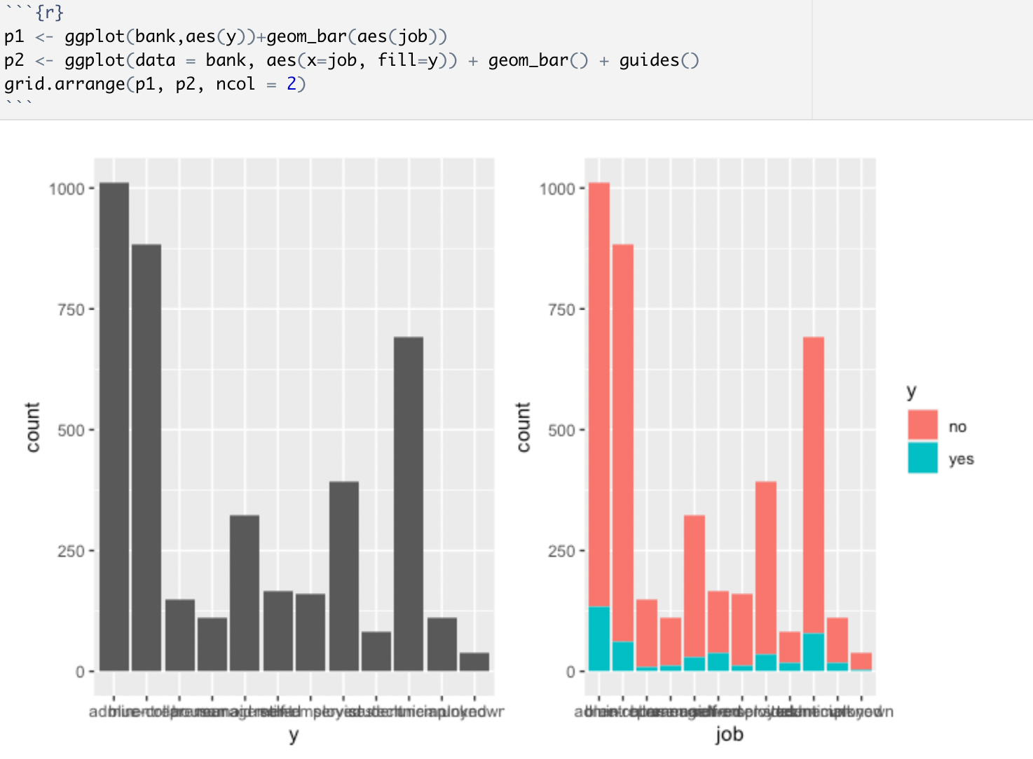

*Fig: collinearity check between the variable job and the target variable*

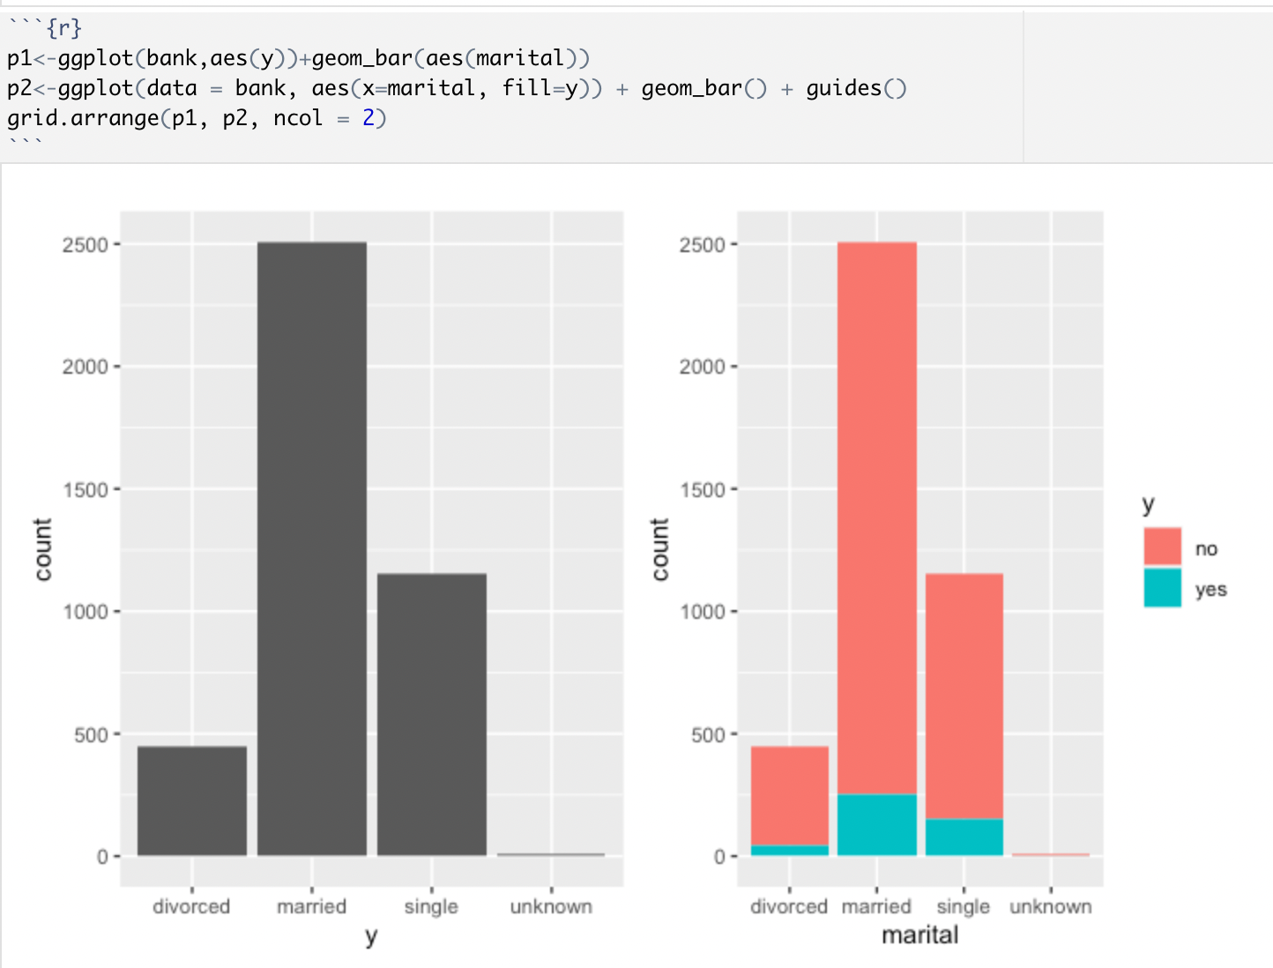

*Fig: collinearity check between the variable marital and the target variable*

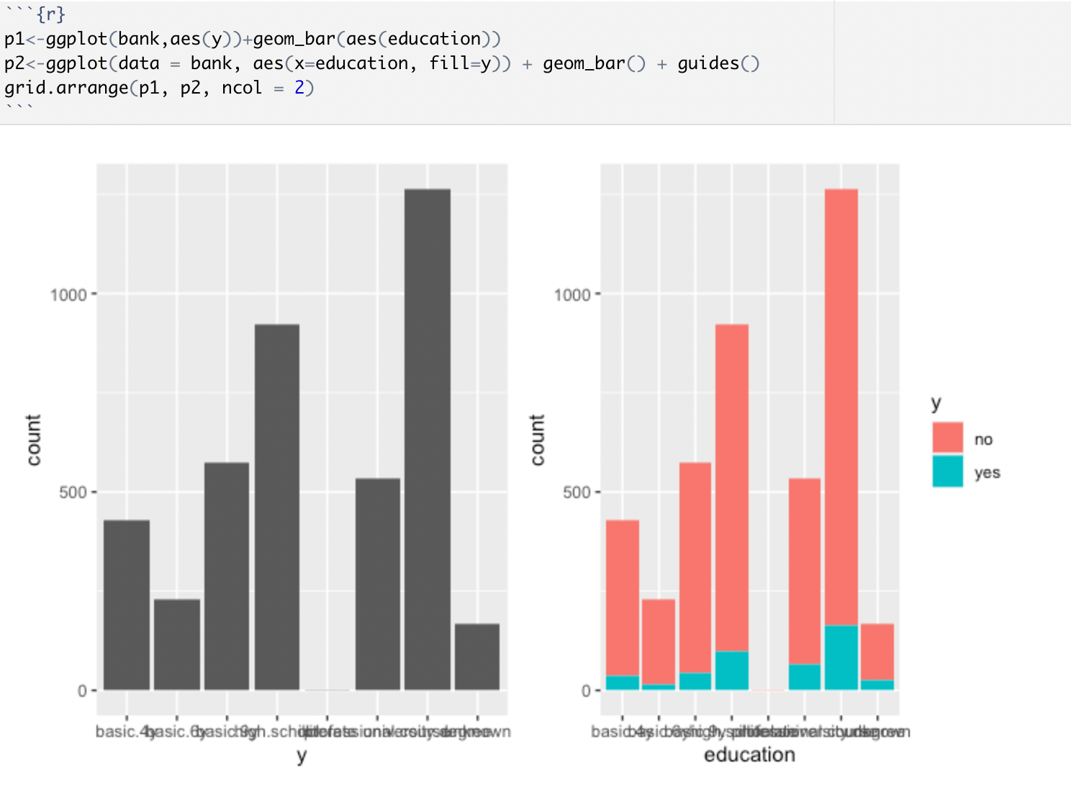

*Fig: collinearity check between the variable education and the target variable*

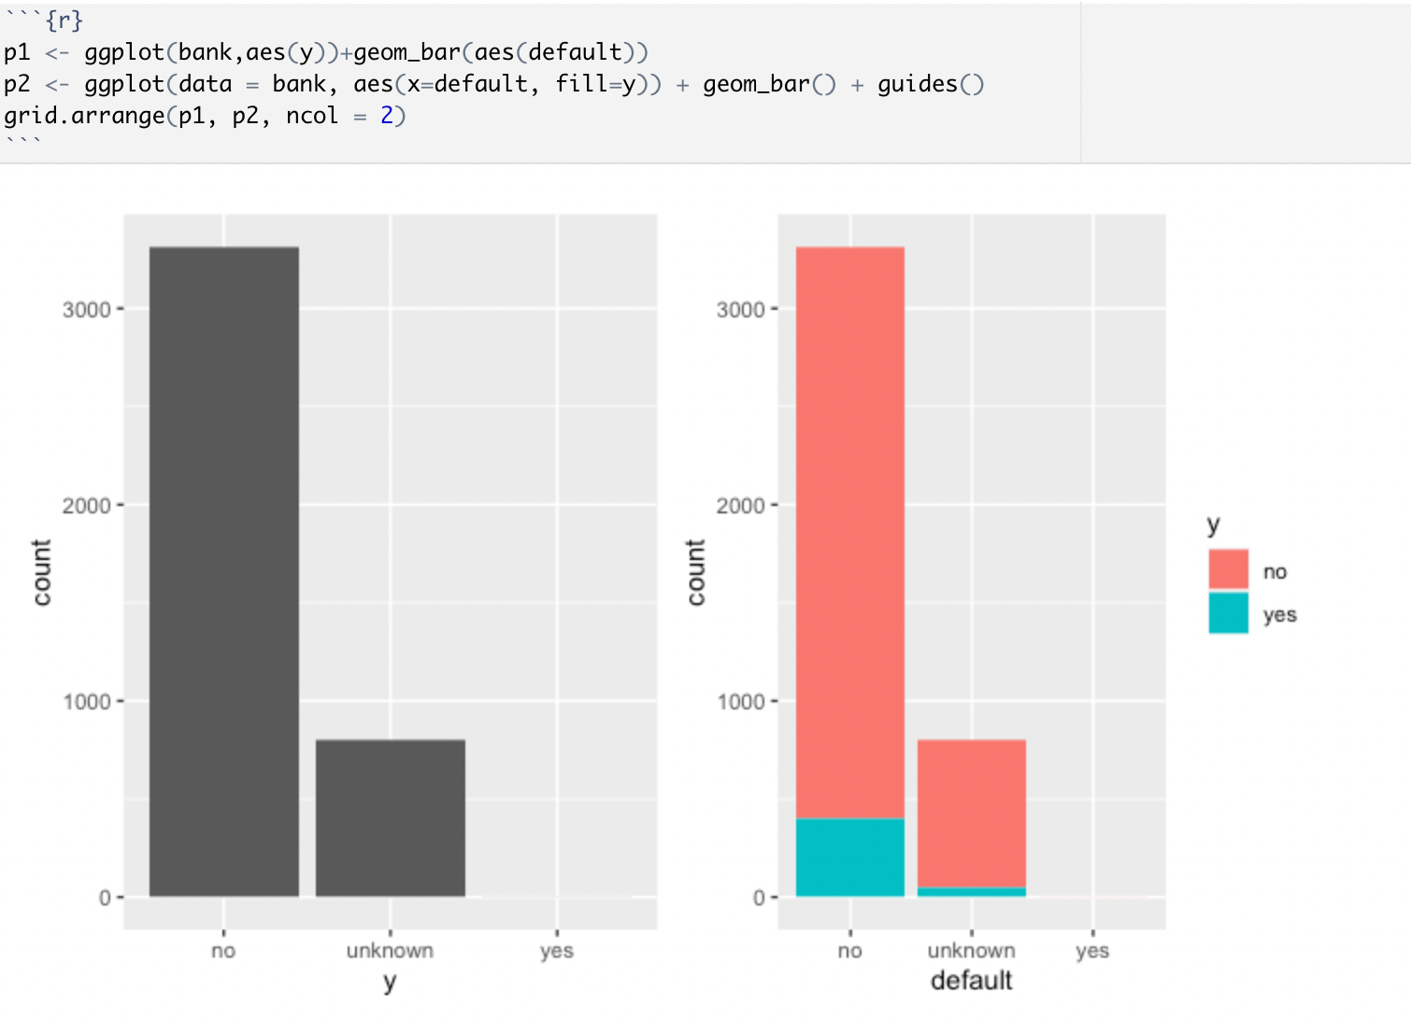

*Fig: collinearity check between the variable default and the target variable*

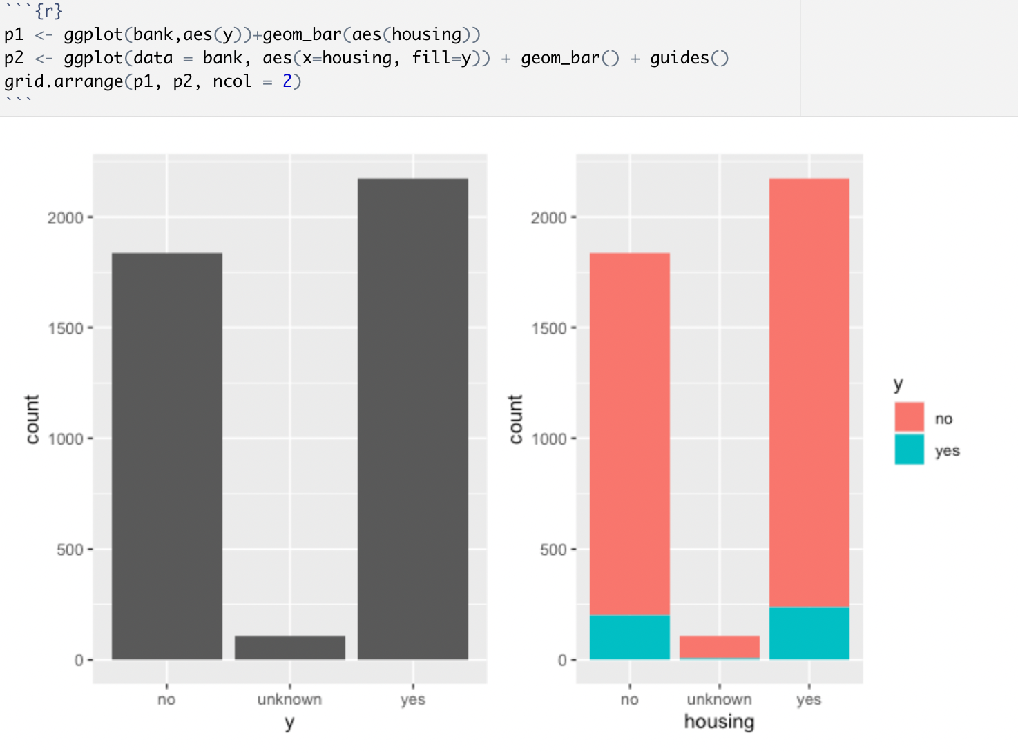

*Fig: collinearity check between the variable housing and the target variable*

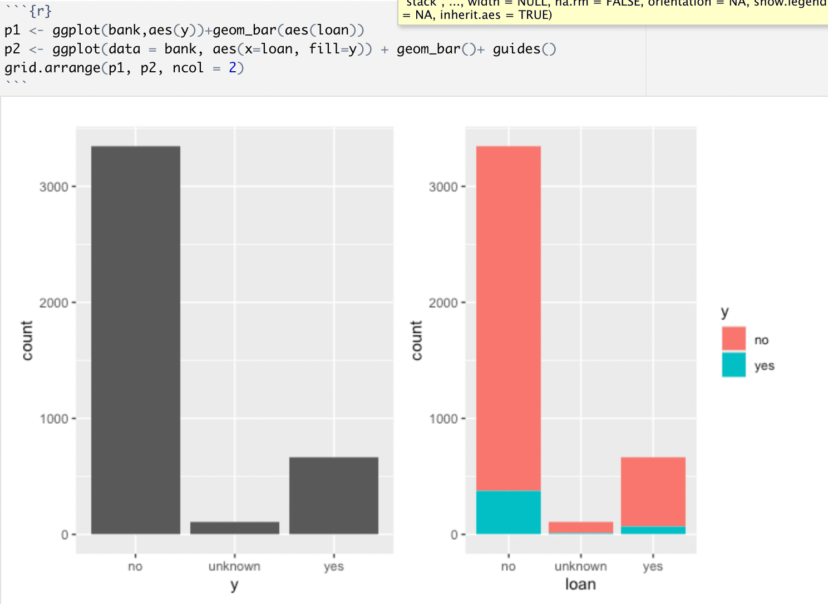

*Fig: collinearity check between the variable loan and the target variable*

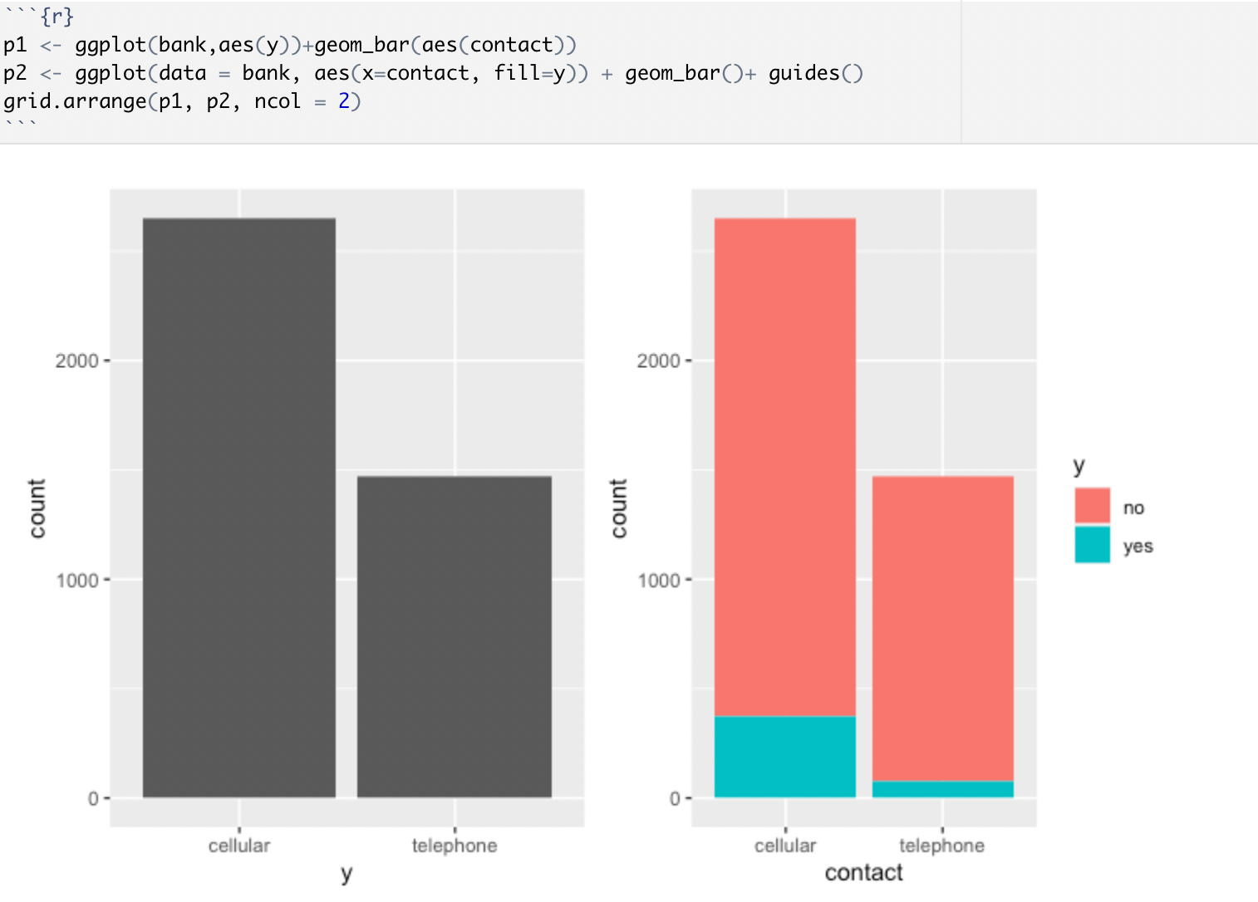

*Fig: collinearity check between the variable contact and the target variable*

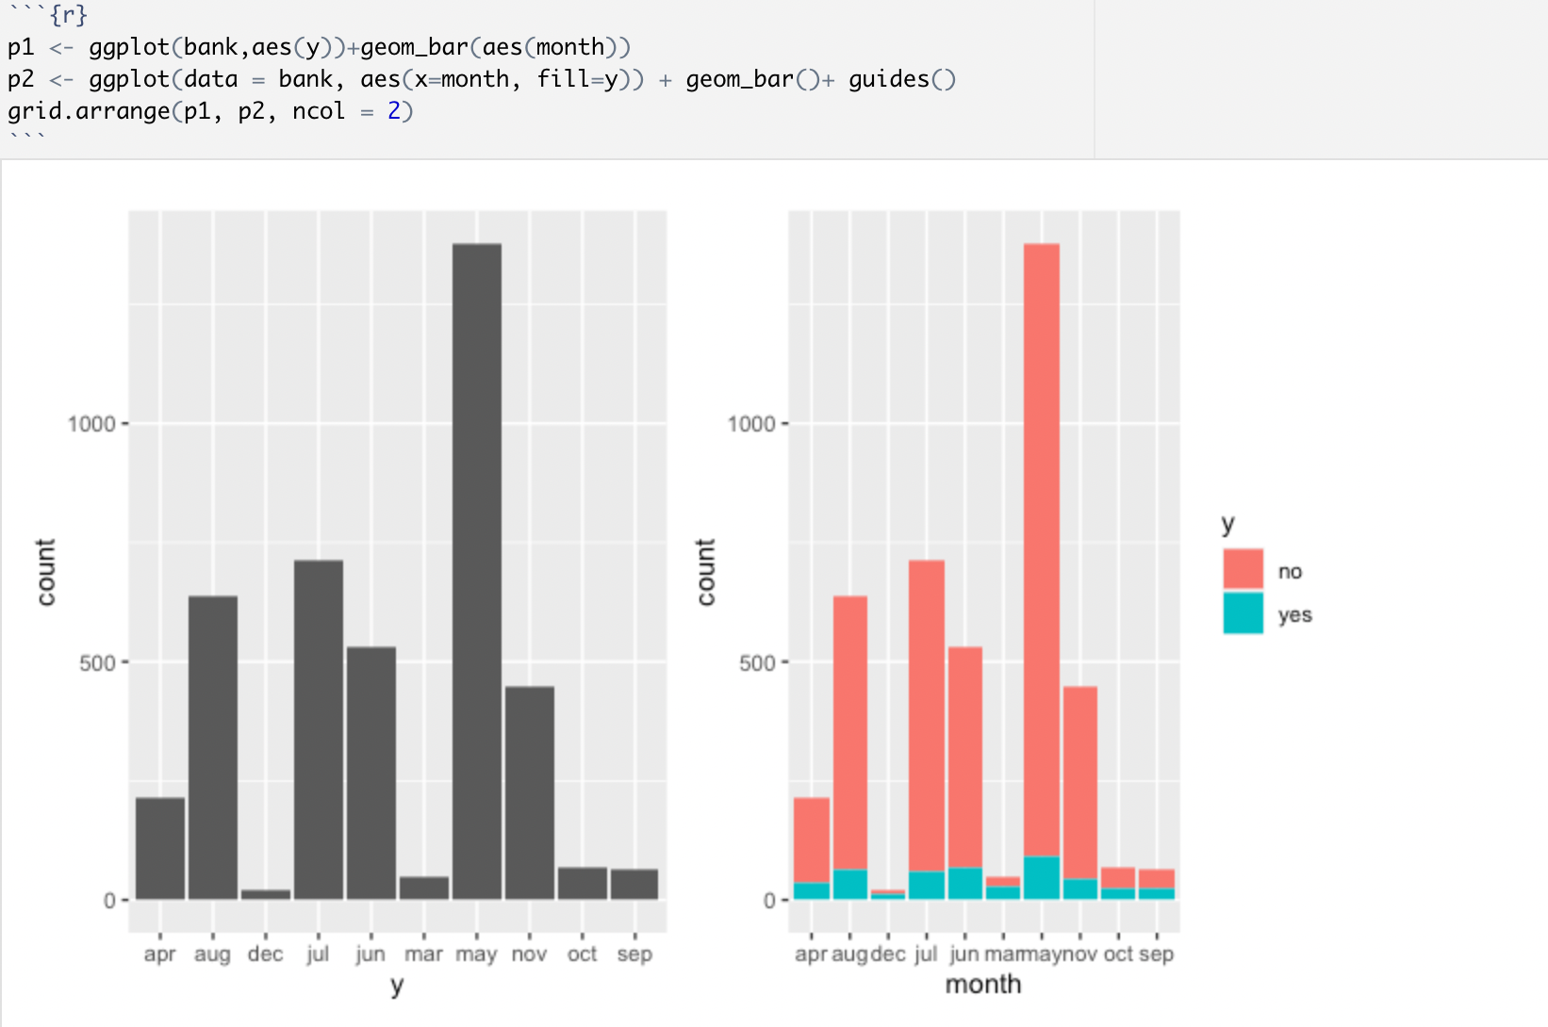

*Fig: collinearity check between the variable month and the target variable*

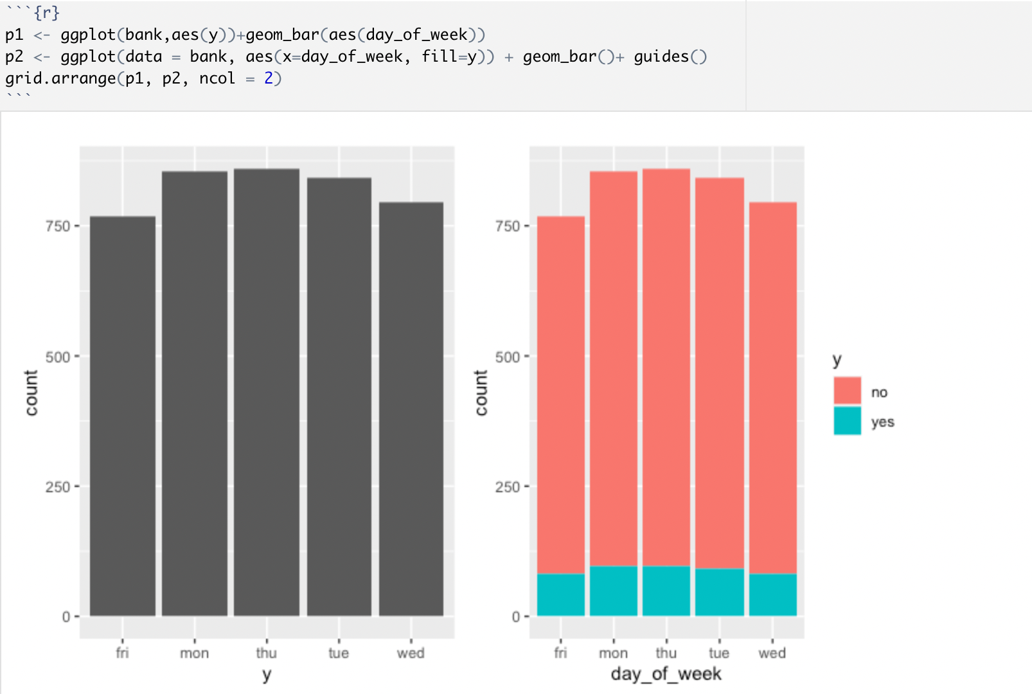

*Fig: collinearity check between the variable day_of_week and the target variable*

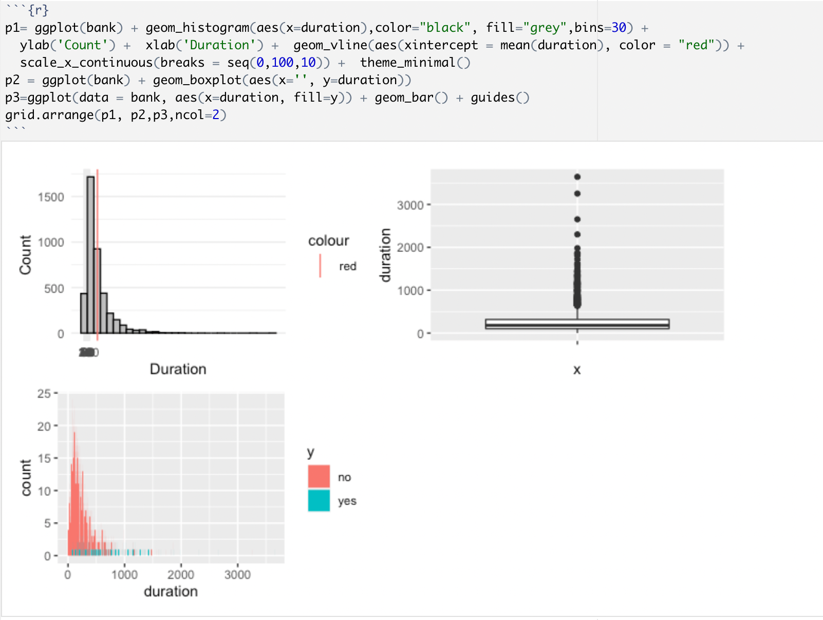

*Fig: collinearity check between the variable duration and the target variable*

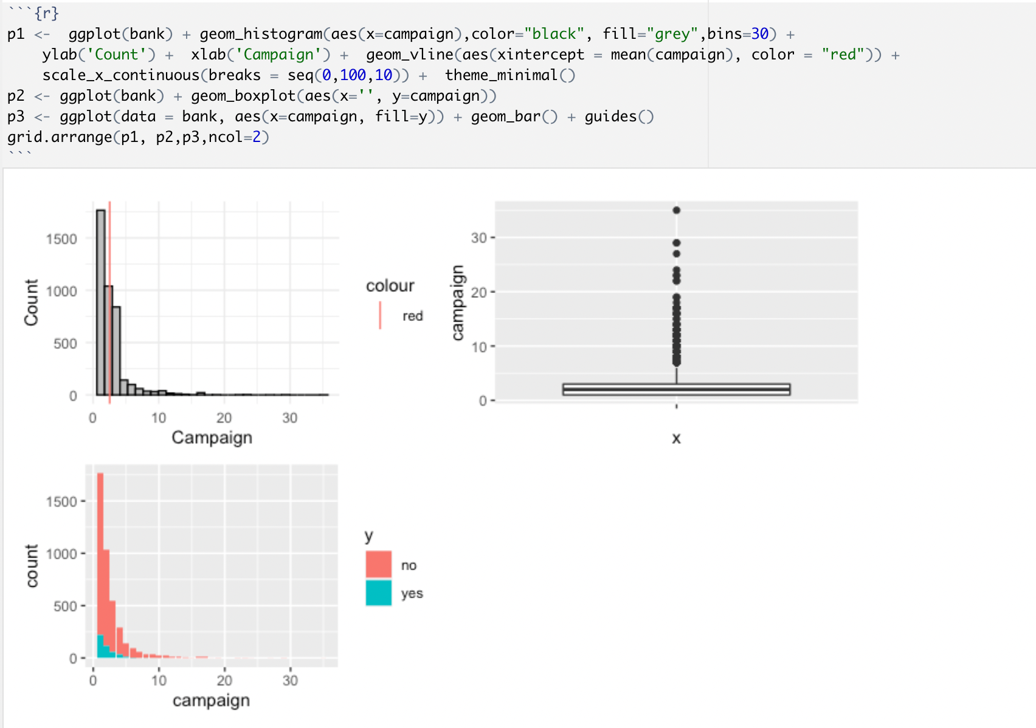

*Fig: collinearity check between the variable campaign and the target variable*

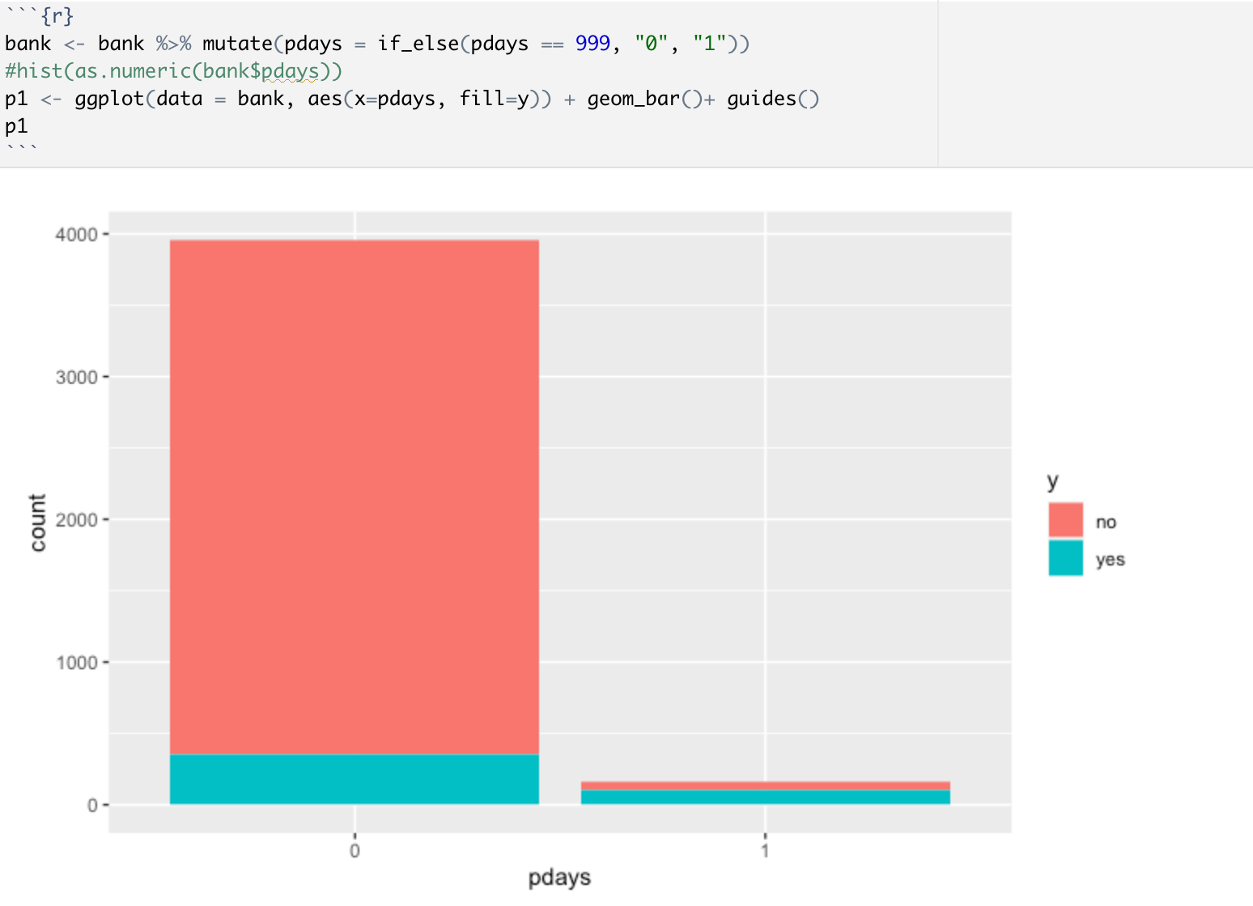

*Fig: collinearity check between the variable p_days and the target variable*

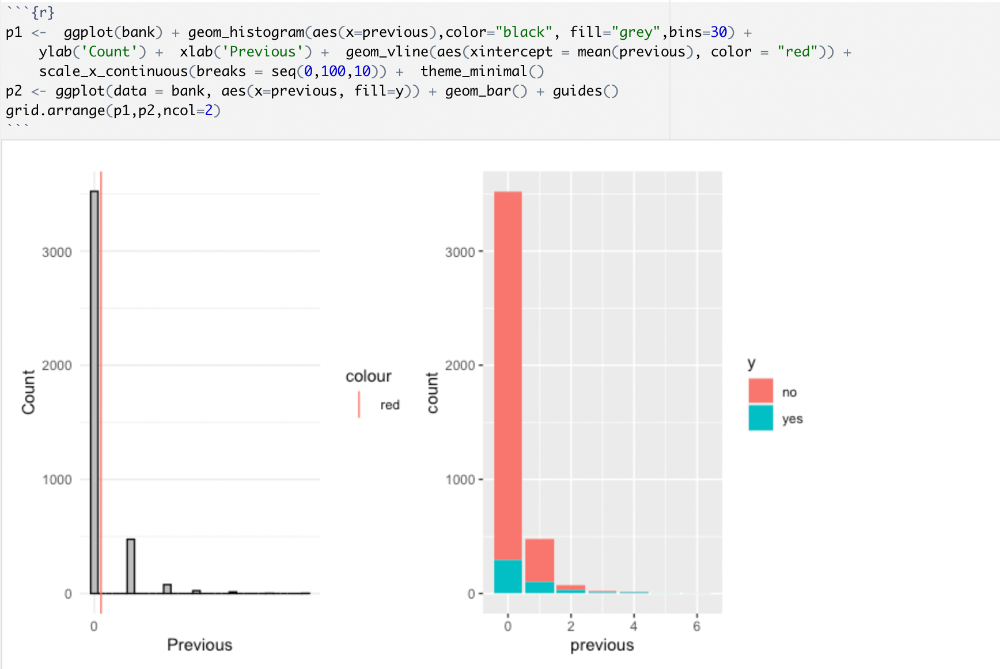

*Fig: collinearity check between the variable previous and the target variable*

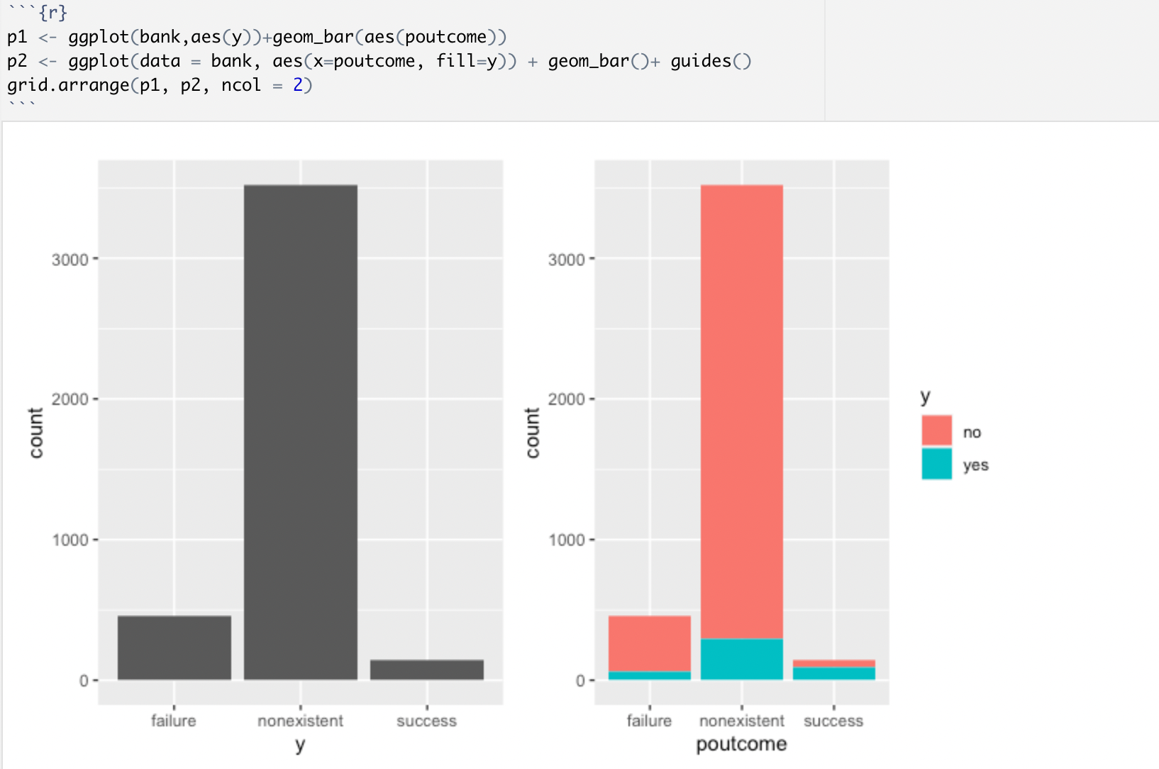

*Fig: collinearity check between the variable poutcome and the target variable*

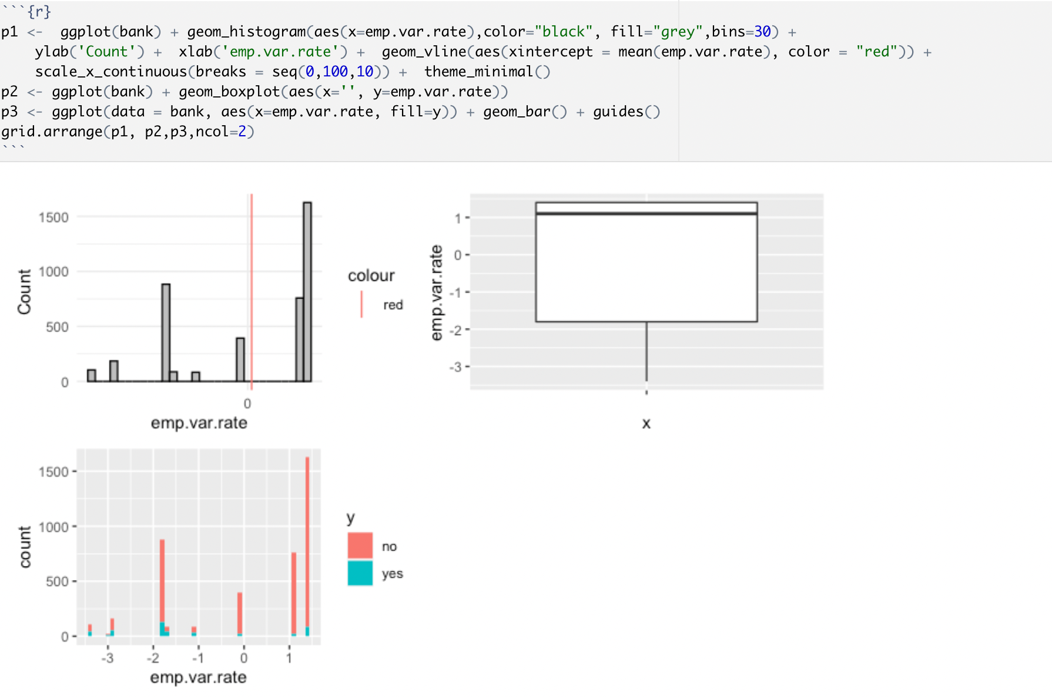

*Fig: collinearity check between the variable age emp.var.rate and the target variable*

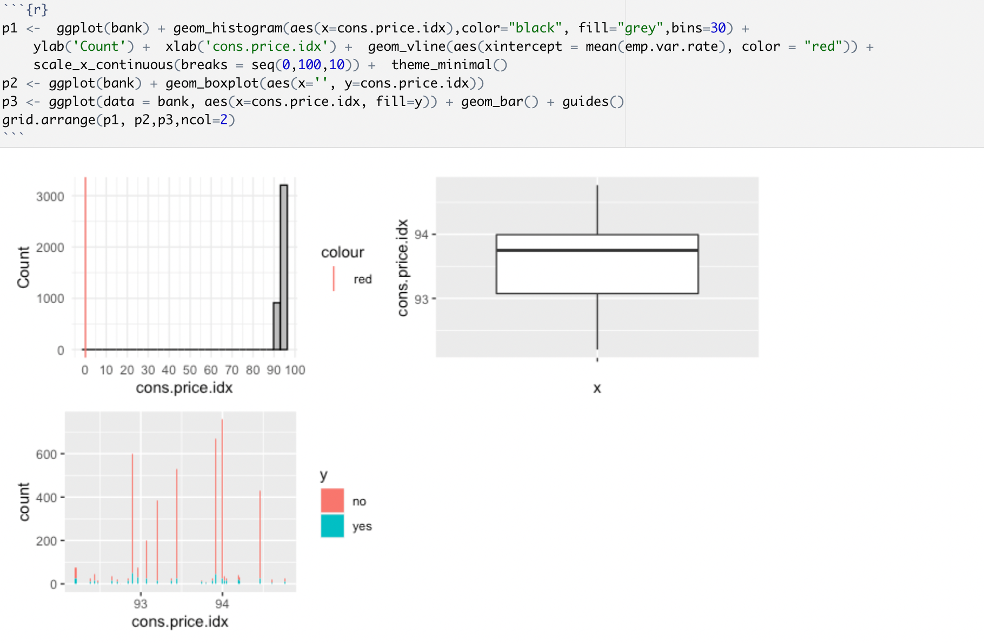

*Fig: collinearity check between the variable cons.price.idx and the target variable*

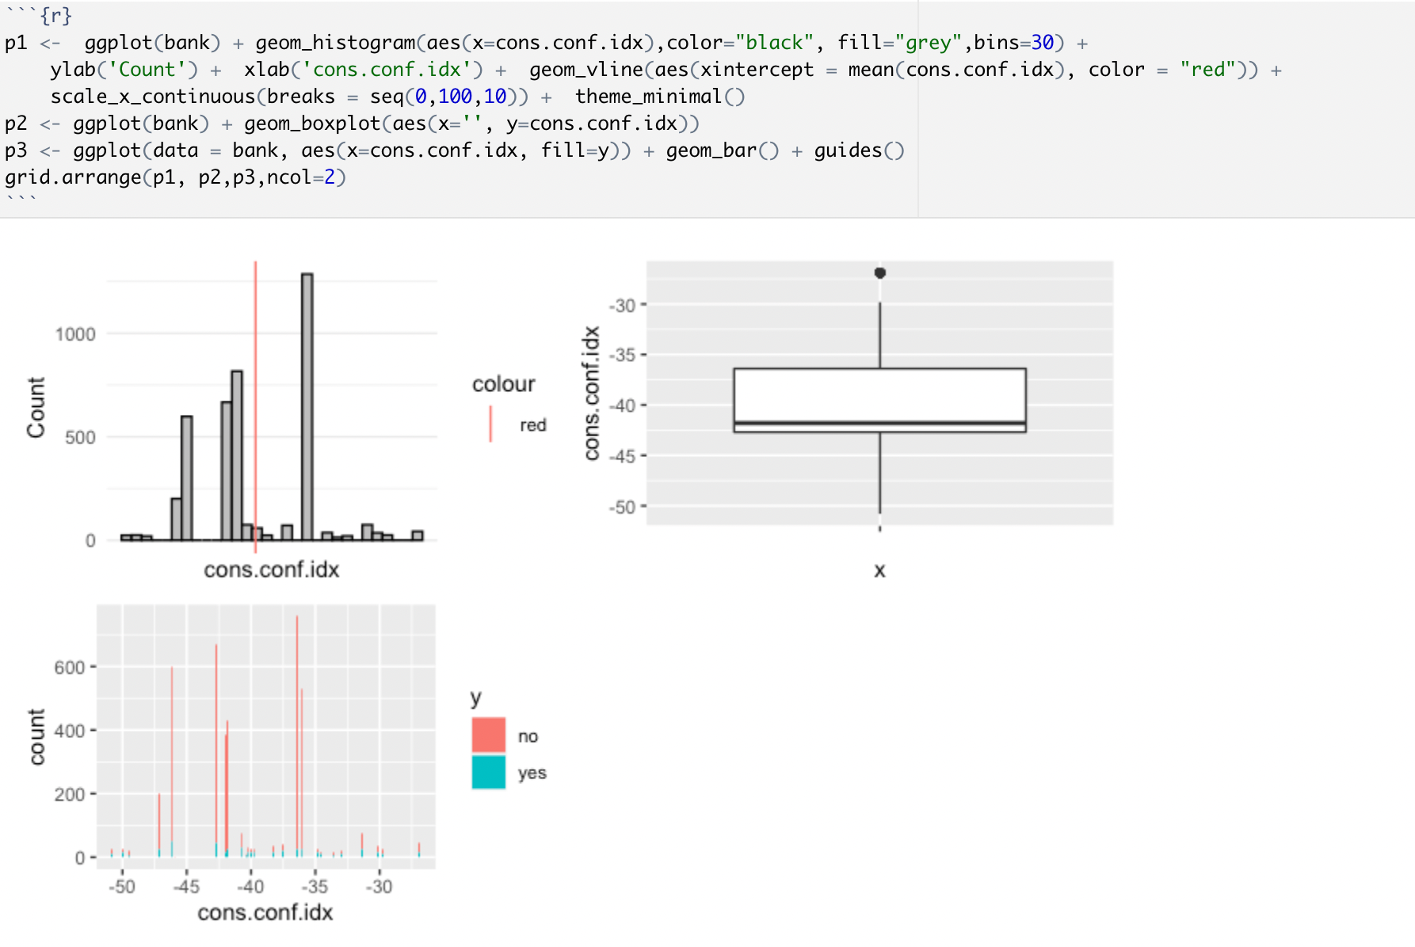

*Fig: collinearity check between the variable cons.conf.idx and the target variable*

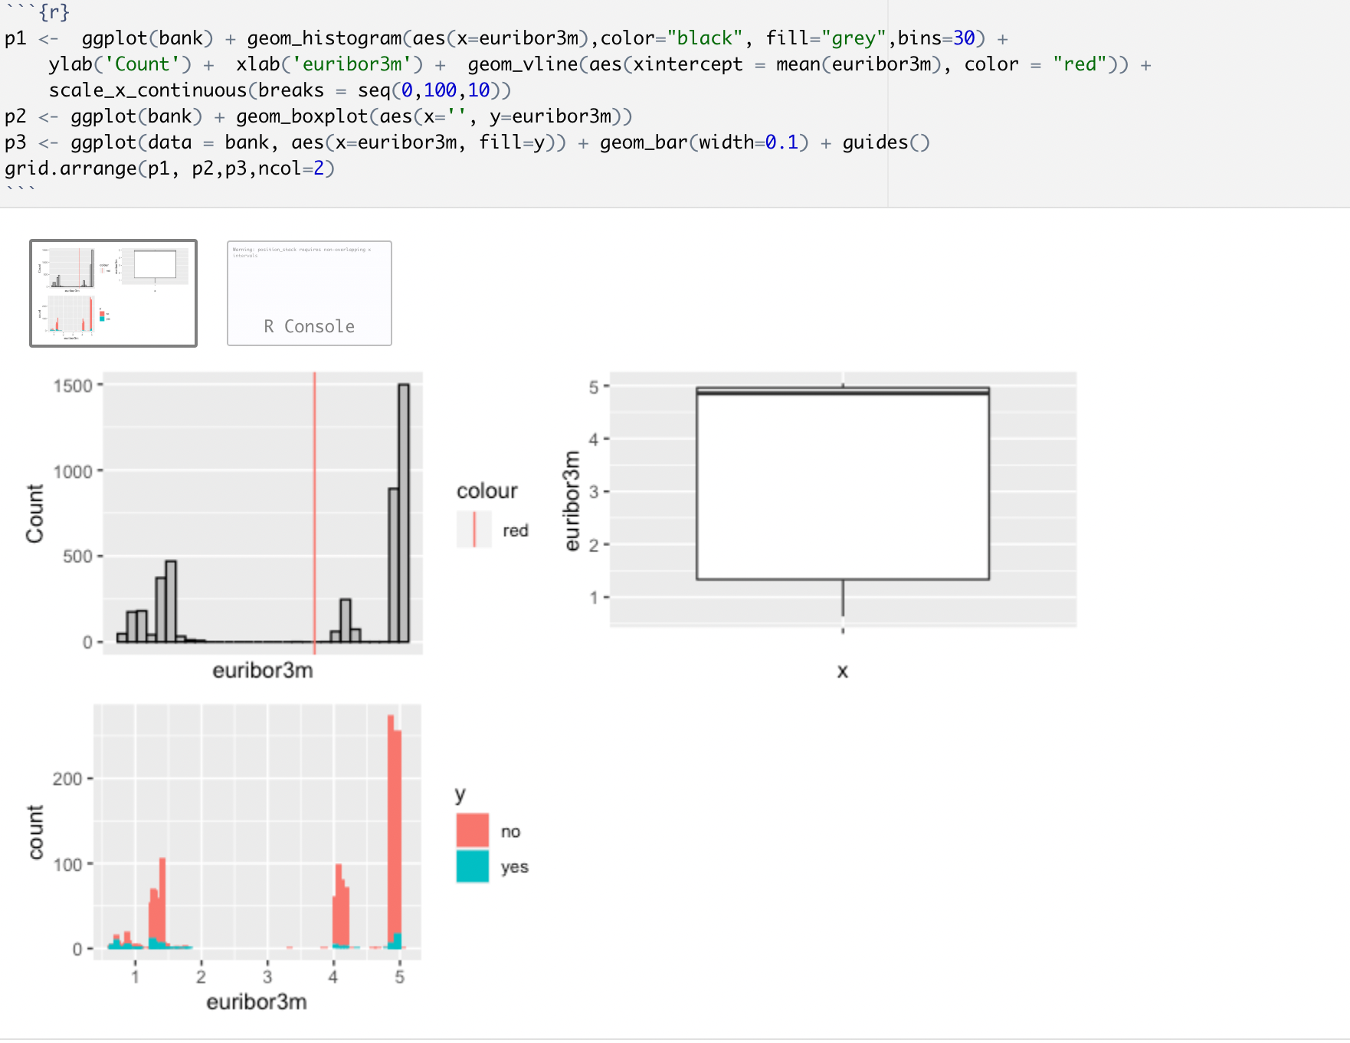

*Fig: collinearity check between the variable euribor3m and the target variable*

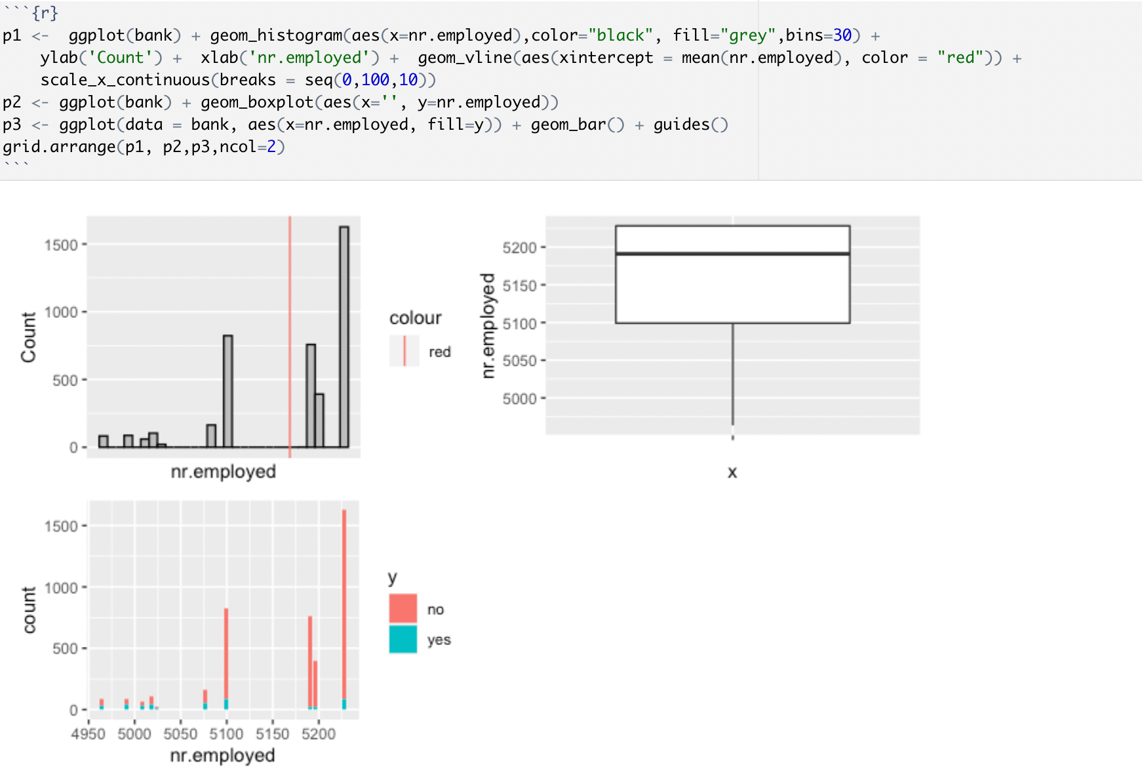

*Fig: collinearity check between the variable nr.employed and the target variable*

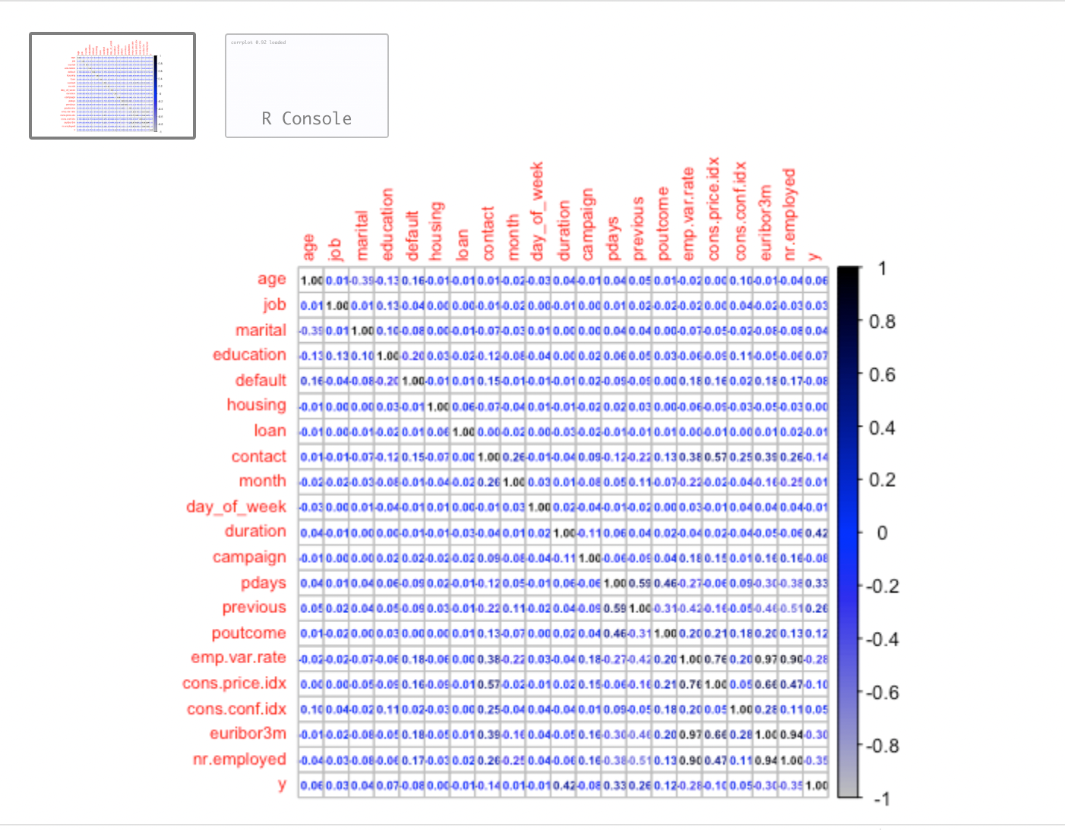

*Fig: collinearity check between all of the variables in the dataset*

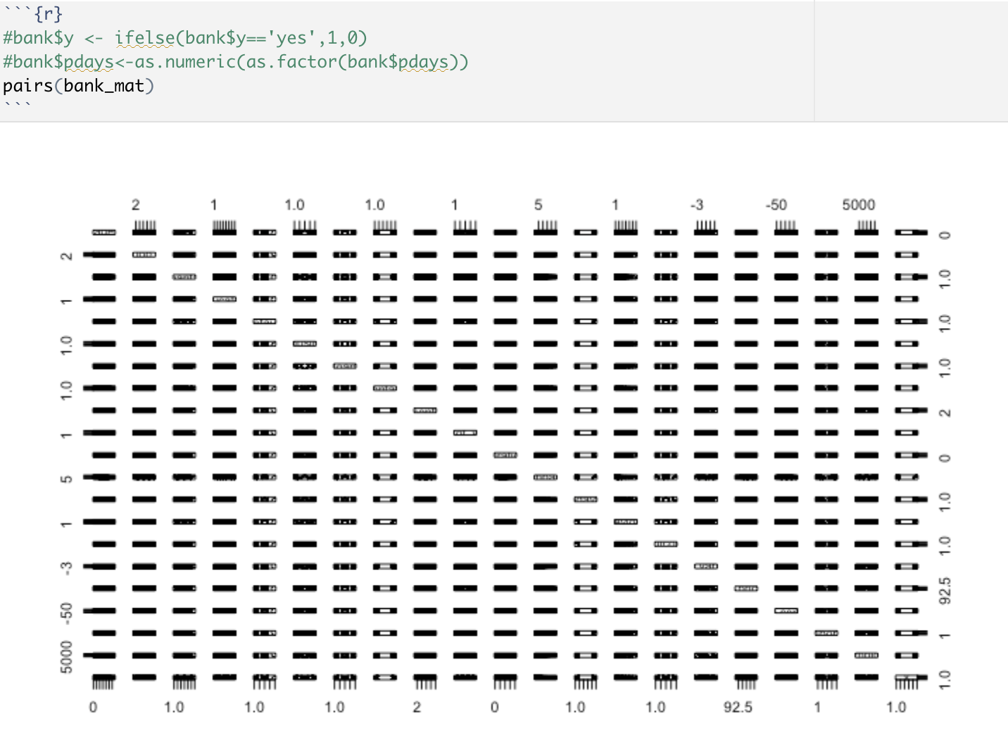

*Fig: pairwise comparison between all the features in the dataset*

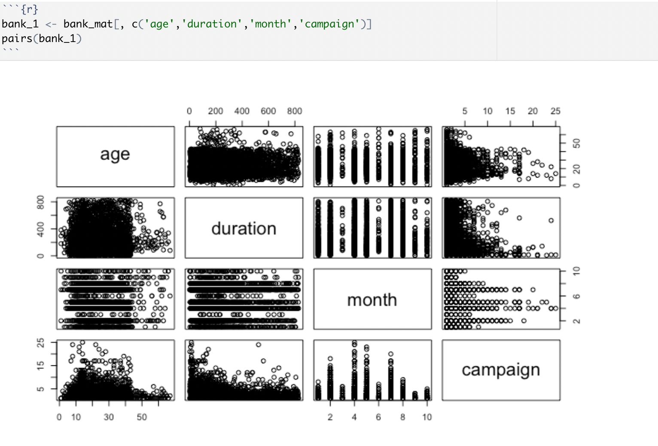

*Fig: pairwise comparison between age, duration, month and campaign*

## Code for the model

